Monday 3rd February 2025
Dear Parents and Carers,
This week it is Children's Mental Health Week with the focus on Know Yourself, Grow Yourself. In school we will be exploring how when we take notice of ourselves and how we feel, we are able to make better choices and be more connected with our feelings and behaviours.
As part of Children’s Mental Health Week we thought it would be useful to revisit with you, our parents and carers, how we explore and talk about emotions in school using ‘The Zones of Regulation’, an intervention which helps children recognise and manage emotions (self-regulation). From time to time all of us find it hard to manage strong feelings such as worry, anger, restlessness, fear or tiredness and this stops us getting on with our day effectively. It is important that we work together to teach all of our children good coping and regulation strategies so they have the tools to help themselves when they experience these emotions.

We aim to help children to:
- Recognise when they are in the different zones and learn how to change or stay in the zone they are in
- Increase their emotional vocabulary so they can explain how they are feeling
- Identify a range of calming and alerting strategies that will help them
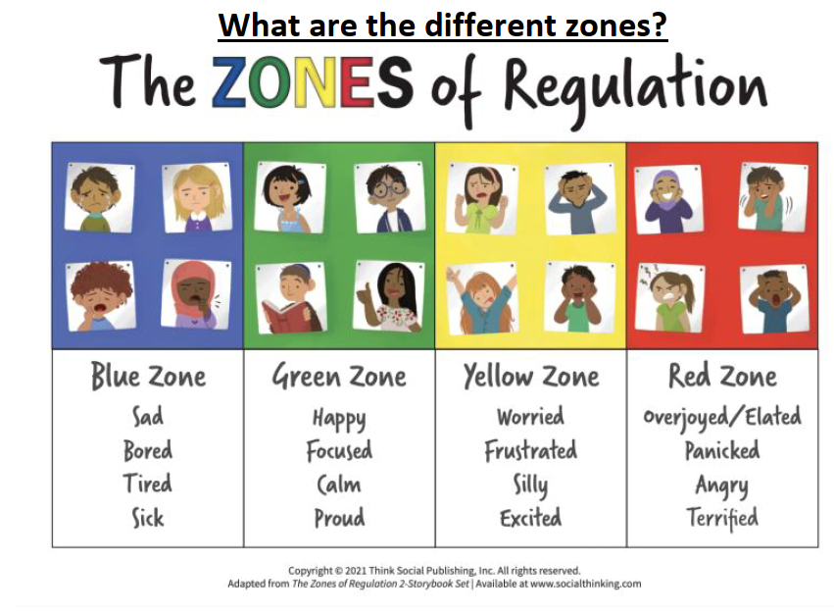
We teach children that everyone experiences all the zones. For example, the red and yellow zones are not ‘bad’ or ‘naughty’ zones. All the zones are expected at one time or another and all the zones are okay.

How can you help your child use the Zones of Regulation at home?
- Model the zones by identifying your own feelings using zones language in front of your child (e.g. “I’m frustrated. I think I am in the yellow zone.”)
- Talk about what tool you will use to be in the appropriate Zone (e.g. “I need to take four deep breathes to help me get back to the green zone.”)
- At times wonder which zone your child is in or discuss which zone a character in a film/ book might be in. (e.g. You look sleepy. Are you in the blue zone?)
- Regular check-ins. “How are you feeling now?” and “What tools can you use to get back into green?”
- Share how their behaviour is affecting your zone. For example, if they are in the green zone, you could comment that their behaviour is also helping you feel happy/go into the green zone.
- Praise and encourage your child when they share which zone they are in.

Where can I find out more about the zones of regulation?
www.zonesofregulation.com
We hope you find this information useful. Please speak to your child’s teacher if you wish to discuss the zones of regulation further or if you have any questions.
Kind Regards,
Mrs Moira Duffy
VSF PSHER Lead
Lead Teacher North Crawley CE First School

